Windows Troubleshooting
& Performance Tweak Guide
Step-by-step fixes for common Windows problems
Covers: Power Plans • Registry Tweaks • Performance • Drivers • OS Repair

Power Plan Management
Export a Power Plan
ℹ️ Run all PowerCFG commands in an elevated (Admin) Command Prompt.
1. Open Start → search "Command Prompt" → Right-click → Run as administrator.
2. List available power schemes: powercfg -list
3. Copy the GUID of your target plan (e.g., c25536bc-... for Ultimate Performance).
4. Export the plan to a .pow file:
powercfg -export D:\UltimatePerformancePowerPlan.pow c25536bc-e7a5-46c2-a306-0183e7ba0967
# Replace the GUID with your own from step 3.

Import a Power Plan
ℹ️ You need the .pow file exported from another machine (see above).
1. Open an elevated Command Prompt on the target machine.
2. Connect the USB/drive containing the .pow file.
3. Verify the plan name does not already exist: powercfg -list
4. Import the plan: powercfg -import D:\UltimatePerformance.pow
5. Confirm it appears in powercfg -list, then set it active in Power Options.

Enable the Default Ultimate Performance Plan
ℹ️ This plan is hidden by default on consumer Windows editions.
1. Open an elevated Command Prompt.
2. Run this command to unlock the plan: powercfg -duplicatescheme e9a42b02-d5df-448d-aa00-03f14749eb61
3. Go to Power Options (Control Panel) → select "Ultimate Performance" → Apply.

Enable Hibernation & Fast Startup
1. Open an elevated Command Prompt and run: powercfg /hibernate on
2. Go to Control Panel → Power Options → Choose what the power buttons do.
3. Check "Turn on fast startup" → Save changes.

Disable Power Throttling
ℹ️ Power Throttling limits CPU performance on laptops to save battery. Disable with caution.
Via Registry:
1. Open regedit (Win+R → regedit).
2. Navigate to: HKLM\SYSTEM\CurrentControlSet\Control\Power\PowerThrottling
3. Set PowerThrottlingOff (DWORD) to 1
Via Group Policy (Pro/Enterprise):
1. Open gpedit.msc.
2. Navigate to: Computer Configuration → Administrative Templates → System → Power Management → Power Throttling Settings.
3. Double-click "Turn off Power Throttling" → set to Enabled → Apply.

Network & Proxy Settings
Reset Proxy to Default
Via Registry (regedit):
1. Open regedit (Win+R → regedit).
2. Navigate to: HKLM\SOFTWARE\Policies\Microsoft\Windows\CurrentVersion\Internet Settings
3. Set ProxySettingsPerUser to 1
4. Navigate to: HKCU\SOFTWARE\Microsoft\Windows\CurrentVersion\Internet Settings
5. Set ProxyEnable to 0
6. Navigate to: HKCU\SOFTWARE\Policies\Microsoft\Windows\Network Connections
7. Set NC_LanProperties to 0
Via Group Policy (Pro/Enterprise):
1. Open gpedit.msc.
2. User Configuration → Administrative Templates → Network → Network Connections → Set "Prohibit access to properties of a LAN connection" to Disabled.
3. User Configuration → Administrative Templates → Windows Components → Internet Explorer → Set "Disable changing proxy settings" to Enabled.

Disable / Enable Wi-Fi via CMD
ℹ️ Replace "Wi-Fi" with your exact adapter name if different. Check with: netsh interface show interface
1. Open an elevated Command Prompt.
2. To enable Wi-Fi: netsh interface set interface name="Wi-Fi" admin=enabled
3. To disable Wi-Fi: netsh interface set interface name="Wi-Fi" admin=disabled

DNS Server Reference
ℹ️ Host file location: C:\Windows\System32\drivers\etc\hosts

Provider | IPv4 Primary | IPv4 Secondary | IPv6 Primary | IPv6 Secondary
Cisco OpenDNS | 208.67.222.222 | 208.67.220.220 | 2620:119:35::35 | 2620:119:53::53
Cloudflare | 1.1.1.1 | 1.0.0.1 | 2606:4700:4700::1112 | 2606:4700:4700::1002
Google Public | 8.8.8.8 | 8.8.4.4 | 2001:4860:4860::8888 | 2001:4860:4860::8844
AdGuard | 94.140.14.15 | 94.140.15.16 | 2a10:50c0::bad1:ff | 2a10:50c0::bad2:ff
CleanBrowsing | 185.228.168.168 | 185.228.169.168 | 2a0d:2a00:1:: | 2a0d:2a00:2::

Performance Tweaks
Disable High Precision Event Timer (HPET)
ℹ️ HPET can add interrupt overhead on some systems. Disabling may reduce CPU latency in games.
1. Open Device Manager → find "High Precision Event Timer" → Right-click → Disable device.
2. Open an elevated Command Prompt and run: bcdedit /deletevalue useplatformclock
3. Run: bcdedit /set disabledynamictick yes
4. Restart the PC.
⤷ To re-enable: bcdedit /set useplatformclock true and bcdedit /set disabledynamictick no

Disable C-States (CPU Power Saving)
⚠️ WARNING: Prevents CPU from entering low-power idle states. Only for desktop PCs where max performance is the priority.
Method 1 — Rename Driver (Safe Mode):
1. Boot into Safe Mode: hold Shift → Restart → Troubleshoot → Advanced → Startup Settings → F4.
2. Navigate to: C:\Windows\System32\Drivers
3. Find intelppm.sys → Rename it to intelppm.sys.bak
4. Reboot normally.
Method 2 — Registry Edit:
1. Open regedit (Win+R → regedit).
2. Navigate to: HKLM\SYSTEM\CurrentControlSet\services\intelppm
3. Change the "start" DWORD value from 3 to 4
4. Restart.

Disable Telemetry
⚠️ WARNING: These commands stop Windows diagnostic data collection. Recommended for privacy-focused setups.
Via CMD (elevated):
1. Open an elevated Command Prompt, then run each line:
2. Stop and delete telemetry services:
sc delete DiagTrack
sc delete dmwappushservice
3. Clear the telemetry log and disable via registry:
echo "" > C:\ProgramData\Microsoft\Diagnosis\ETLLogs\AutoLogger\AutoLogger-Diagtrack-Listener.etl
reg add "HKLM\SOFTWARE\Policies\Microsoft\Windows\DataCollection" /v AllowTelemetry /t REG_DWORD /d 0 /f
Via PowerShell (elevated):
1. Run: Stop-Service diagtrack
2. Run: Set-Service diagtrack -StartupType Disabled

Disable Dynamic Platform & Thermal Framework (DPTF)
ℹ️ Intel DPTF throttles CPU to manage thermals. Removing it gives more headroom but may increase temperatures.
Method 1 — Device Manager + Services:
1. Open Device Manager → System Devices → Uninstall all "Intel Dynamic Platform and Thermal Framework" entries.
2. Open Task Manager → Services tab → "Open Services" → Disable all Intel DPTF services.
3. Apply NoDPTF.reg if available in your deployment package.
4. Boot into Safe Mode.
5. Navigate to: C:\Windows\System32\DriverStore\FileRepository
6. Delete all folders whose name contains "DPTF".
7. Restart.
Method 2 — Group Policy:
1. Open gpedit.msc.
2. Navigate to: Computer Configuration → Administrative Templates → System → Device Installation → Device Installation Restrictions.
3. Enable "Prevent installation of devices that match any of these device IDs".
4. Check "Also apply to matching devices that are already installed".
5. Click Show → enter each DPTF device's Hardware ID (find in Device Manager → Properties → Details → Hardware IDs).
6. Click OK. DPTF devices will show as "Unknown device" — that confirms they are disabled.

Force Enable ReadyBoost
ℹ️ ReadyBoost is only beneficial on systems with slow HDDs. Windows auto-disables it on SSDs.
Method 1 — Registry AttachState:
1. Open regedit → navigate to: HKLM\SYSTEM\CurrentControlSet\services\rdyboost\AttachState
2. Set ALL values in the right panel to 0
3. Format your USB drive as NTFS (required for ReadyBoost).
4. Reconnect USB → check ReadyBoost in its Properties.
Reference:
🔗 Force Enabling ReadyBoost — HatsOffSecurity
Method 2 — Clear EMDMgmt Registry:
1. Open regedit → navigate to: HKLM\SOFTWARE\Microsoft\Windows NT\CurrentVersion\EMDMgmt
2. Delete all subkeys.
3. Reconnect USB → check ReadyBoost.
Method 3 — Manually Set Device Values:
1. Open regedit → navigate to: HKLM\SOFTWARE\Microsoft\Windows NT\CurrentVersion\EMDMgmt\[YOUR DEVICE KEY]
⤷ Example key: _??_USBSTOR#Disk&Ven_ADATA&Prod_SD_Storage...
2. Set DeviceStatus DWORD to 2 (was 6)
3. Create a new QWORD (64-bit) named SpeedReadKBs → set value to 1000 (Decimal)
4. Reboot and reconnect the USB drive.
Reference:
🔗 ReadyBoost Fix — YouTube Tutorial (Methods 2 & 3)

File & System Fixes
Reveal Files Hidden by a Virus (USB Drive)
1. Open an elevated Command Prompt.
2. Replace X with your USB drive letter and run: ATTRIB -h -r -s /s /d X:\*.*
⤷ -h = remove hidden | -r = remove read-only | -s = remove system | /s = subfolders | /d = directories

Fix Corrupted or White Desktop Icons
Method 1 — Delete IconCache via File Explorer:
1. Press Win+R → type %appdata%
2. Go up one folder → open the "Local" folder.
3. Show hidden items: View → check "Hidden items".
4. Delete IconCache.db
5. Empty the Recycle Bin.
6. Restart the PC (icon rebuild may slow first boot slightly).
Method 2 — Delete IconCache via CMD (no reboot):
1. Close all File Explorer windows.
2. Open Task Manager (Ctrl+Shift+Esc) → Processes → Right-click explorer.exe → End Task.
3. File → Run new task → type cmd.exe
4. Run these commands one by one:
null.
CD /d %userprofile%\AppData\Local
DEL IconCache.db /a
EXIT
5. In Task Manager: File → Run new task → type explorer.exe
6. Click the desktop and press F5 to refresh.

Fix Corrupted Windows OS
ℹ️ Run in this exact order: SFC first, then DISM only if SFC cannot repair all files.
1. Open an elevated Command Prompt.
2. Scan and repair system files: sfc /scannow
3. Check DISM image health: Dism /Online /Cleanup-Image /CheckHealth
4. Scan for issues: Dism /Online /Cleanup-Image /ScanHealth
5. Restore health: Dism /Online /Cleanup-Image /RestoreHealth
6. If step 5 fails, point to a local source:
null.
Dism /Online /Cleanup-Image /RestoreHealth /Source:c:\test\mount\windows /LimitAccess
⤷ Alternative if mountpoints are corrupted: Dism /Cleanup-Mountpoints

Fix DISM Error 50 — "Does not support servicing Windows PE"
ℹ️ This happens when a MiniNT registry key incorrectly marks Windows as a PE environment.
1. Open Run (Win+R) → type regedit.exe
2. Navigate to: HKLM\SYSTEM\CurrentControlSet\Control\MiniNT
3. Right-click MiniNT → Delete.
4. Close Registry Editor. No restart needed — run DISM again.

Fix Missing DLL Errors (msvcp140 / mfc140u)
ℹ️ Method 3 (reinstalling Visual C++ Redistributable) is always the recommended fix.
Method 1 — Manual DLL Placement:
1. Download the DLL from a trusted source:
🔗 msvcp140_codecvt_ids.dll — DLL-Files.com
🔗 mfc140u.dll — DLL-Files.com
2. For 64-bit systems: copy the file to C:\Windows\System32\
3. For 32-bit systems: copy the file to C:\Windows\SysWOW64\
Method 2 — Register the DLL:
1. Open an elevated Command Prompt.
2. For 64-bit DLL on 64-bit Windows: regsvr32 msvcp140_codecvt_ids.dll
3. For 32-bit DLL on 64-bit Windows:
null.
cd c:\windows\syswow64
regsvr32 c:\windows\syswow64\msvcp140_codecvt_ids.dll
4. Restart the PC.
Method 3 — Install Visual C++ Redistributable (Recommended):
1. Download the all-in-one package:
🔗 Visual C++ Redistributable All-in-One — TechPowerUp
2. Run the installer and follow the prompts.
3. Restart the PC.

System Administration
Built-in Administrator Account
ℹ️ This account is disabled by default. Enable only for troubleshooting, then re-disable.
1. Open an elevated Command Prompt.
2. To enable: net user administrator /active:yes
3. To disable: net user administrator /active:no
4. To change password (replace with actual password): net user administrator "YourNewPassword"

Disable Windows Automatic Updates
⚠️ WARNING: Disabling updates removes critical security patches. Only do this on isolated/dev machines or when managing updates manually.
Method 1 — Group Policy (Pro/Enterprise):
1. Open gpedit.msc
2. Navigate to: Computer Configuration → Administrative Templates → Windows Components → Windows Update.
3. Double-click "Configure Automatic Updates" → set to Disabled → Apply → OK.
Method 2 — Registry Edit:
1. Open regedit
2. Navigate to: HKLM\SOFTWARE\Policies\Microsoft\Windows
3. Right-click Windows key → New → Key → name it WindowsUpdate
4. Right-click WindowsUpdate → New → Key → name it AU
5. Inside AU: right-click right panel → New → DWORD (32-bit) → name it NoAutoUpdate
6. Double-click NoAutoUpdate → set value to 1
7. Restart the PC.

Change Windows Lock Screen Manually
ℹ️ Replace %USERPROFILE% with your actual path, e.g. C:\Users\YourName
1. Copy your image to: C:\Windows\Web\Screen
2. Copy the same image (no extension) to:
⤷ %USERPROFILE%\AppData\Local\Packages\Microsoft.Windows.ContentDeliveryManager_cw5n1h2txyewy\LocalState\Assets
⤷ Tip: Files here without extensions are cached lock screens — add .jpg to recover old ones.
3. Remove the existing image from:
⤷ C:\ProgramData\Microsoft\Windows\SystemData\[SID]\ReadOnly\LockScreen_W
4. Paste your new image into that same folder.
⤷ Your SID is found under: HKLM\SOFTWARE\Microsoft\Windows NT\CurrentVersion\ProfileList

GodMode Folder
ℹ️ Gives instant access to 200+ Windows settings in one organized place.
1. Create a new folder anywhere on your Desktop.
2. Rename the folder to exactly: GodMode.{ED7BA470-8E54-465E-825C-99712043E01C}
3. The icon changes to Control Panel. Open it to access all settings.

Fix ctfmon.exe Not Starting Automatically
ℹ️ ctfmon.exe manages alternative input methods like handwriting and speech.
1. Open File Explorer → paste in the address bar and press Enter: shell:common startup
2. Right-click in the folder → New → Shortcut.
3. Set location to: C:\Windows\System32\Ctfmon.exe
4. Click Next → name it "Ctfmon" → Finish.
5. ctfmon.exe will now auto-launch at every startup.

Upgrade Windows 10 IoT LTSC 2021 from 21H2 to 22H2
ℹ️ Windows 10 IoT LTSC 2021 does not receive feature updates via Windows Update. Use the official enablement package from Microsoft to manually upgrade from version 21H2 (OS build 19044) to 22H2 (OS build 19045).
1. Download the 22H2 enablement package from Microsoft’s official link:
https://catalog.s.download.windowsupdate.com/c/upgr/2022/07/windows10.0-kb5015684-x64_523c039b86ca98f2d818c4e6706e2cc94b634c4a.msu
2. Extract the .msu file to a folder using WinRAR or 7-Zip. Then extract the contents of the Windows10.0-KB5015684-x64_PSFX.cab file (that came out of the first extraction) to a separate folder, also using WinRAR or 7-Zip.
3. Move the folder containing the extracted CAB contents to an easily accessible location (e.g., the root of the C: drive). Example path: C:\Windows10.0-KB5015684-x64_PSFX
4. Run PowerShell as an administrator, then enter the following commands in order:
cd C:\Windows10.0-KB5015684-x64_PSFX
Dism /online /add-package /packagepath:microsoft-windows-22h2enablement-package~31bf3856ad364e35~amd64~~10.0.19041.1799.mum
⤵️ Adjust the first command if your folder name differs. After the second command runs, you will be prompted to restart — press Y to accept.
After restarting, open Run (Win+R) → type winver to confirm. The version should now show 22H2 and OS build 19045.
To Uninstall / Roll Back to 21H2:
cd C:\Windows10.0-KB5015684-x64_PSFX
Dism /online /remove-package /packagename:microsoft-windows-22h2enablement-package~31bf3856ad364e35~amd64~~10.0.19041.1799
⤵️ After uninstalling and restarting, the OS should revert to version 21H2 and OS build 19044.

Drivers & Virtualization
Fix NVIDIA GeForce Error 14109
ℹ️ Caused by the NVIDIA telemetry service lacking write permissions to its data folder.
1. Open C:\ProgramData
2. Right-click "NVIDIA Corporation" folder → Properties → Security tab → Edit.
3. Click Add → type Everyone
4. Check "Full Control" → Apply → OK.
5. Open Services: Win+X → Run → services.msc
6. Find "NVIDIA Telemetry Container" → Right-click → Properties → Start.
References:
🔗 [FIX] GeForce Experience / NV Telemetry 14109 — Reddit r/GeForceExperience
🔗 Error 14109 — NVIDIA GeForce Forums

Fix Incompatible JVM for Eclipse IDE
ℹ️ Eclipse requires a matching JVM. Specify the correct path manually in eclipse.ini.
1. Find your Eclipse installation folder.
2. Open eclipse.ini
3. Find the line that says -vmargs
4. Insert these two lines DIRECTLY above -vmargs:
null.
-vm
C:\Program Files\Java\jdk-11.0.9\bin\javaw.exe
5. Save the file and launch Eclipse.
⤷ Adjust the JDK path to match your actual installation.

Enable or Disable Hyper-V
⚠️ WARNING: Hyper-V may conflict with VMware, VirtualBox, and anti-cheat software (Vanguard, EasyAntiCheat). Disable if you hit compatibility issues.
To Enable:
1. Control Panel → Programs → Turn Windows features on or off → check Hyper-V → OK → Restart.
2. Or via CMD/PowerShell (Admin): DISM /Online /Enable-Feature /FeatureName:Microsoft-Hyper-V -All
To Disable:
1. Control Panel → uncheck Hyper-V → OK → Restart.
2. Or via CMD/PowerShell (Admin): dism.exe /Online /Disable-Feature /FeatureName:Microsoft-Hyper-V-All
Reference:
🔗 Methods to Enable/Disable Hyper-V in Windows 11 — PromptResolve

Install Google Play Store on Windows 11
ℹ️ Requires Windows Subsystem for Android (WSA) and ADB. Developer Mode must be enabled.
1. Control Panel → Programs → Windows Features → Enable: Hypervisor Platform, Hyper-V, Virtual Machine Platform, Windows Subsystem for Linux → Restart.
2. Enable Developer Mode: Settings → System → Developer Mode → On.
3. Install ADB (Android Debug Bridge).
4. Paste the WSA Package to your C:\ directory.
5. Open PowerShell as Admin → cd to WSA folder → run: Add-AppxPackage -Register .\AppxManifest.xml
6. After WSA installs, open it and enable Developer Mode inside it.
7. Click Files in WSA to begin Google Play Store installation.
8. Navigate to your ADB folder → type "CMD" in the address bar → Enter.
9. Connect and authorize:
null.
adb connect [WSA_IP_ADDRESS]
adb shell
su
setenforce 0
10. Open Google Play Store and sign in to your Google Account.
Reference:
🔗 Install Google Play Store on Windows 11 — YouTube Tutorial

Prevent Chrome Extensions from Being Uninstalled
ℹ️ Uses Registry to force-install extensions so users cannot remove them.
1. Open regedit → navigate to: HKLM\SOFTWARE\Policies\Google\Chrome
2. Create each missing key manually if the path does not exist.
3. Create a new String Value for each extension, naming them 1, 2, 3... sequentially.
4. Set each value in this format: extensionID;update_url
⤷ Enhancer for YouTube: ponfpcnoihfmfllpaingbgckeeldkhle;https://clients2.google.com/service/update2/crx
⤷ Improve YouTube: bnomihfieiccainjcjblhegjgglakjdd;https://clients2.google.com/service/update2/crx
Reference:
🔗 Prevent Uninstallation of Chrome Extensions — TheWindowsClub

Fix Blank White/Black Screen on Chromium Browsers
ℹ️ Caused by GPU rendering conflicts. Adding --disable-gpu bypasses hardware acceleration.
Screenshot — Blank white screen on browser launch:
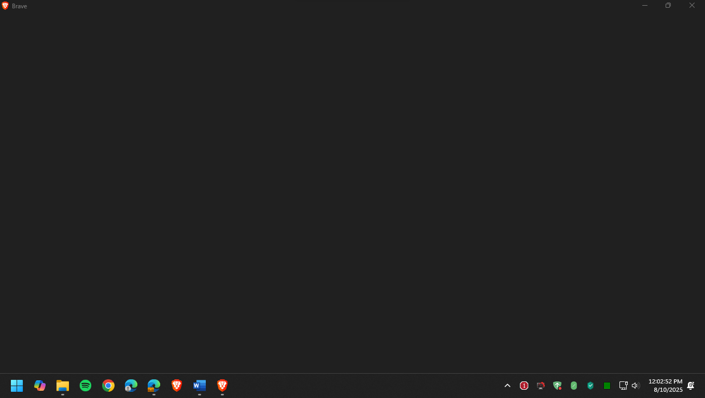
1. Close the browser completely.
2. Right-click the browser shortcut on your Desktop → Properties.
3. In the Target field, append --disable-gpu (after the closing quote)
⤷ Example: "C:\Program Files\Google\Chrome\Application\chrome.exe" --disable-gpu
Screenshot — Adding --disable-gpu to the Target field:
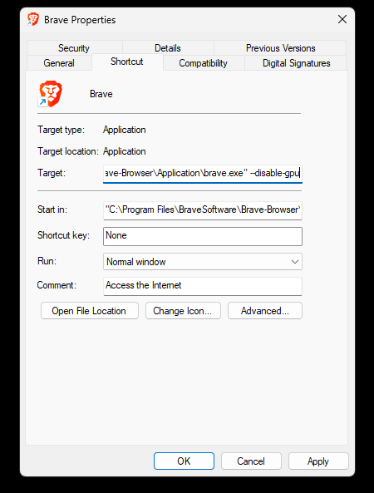
4. Click Apply → OK → launch the browser from this shortcut.
⤷ Permanent fix: Settings → System → "Use hardware acceleration when available" → toggle OFF.

Quick Reference — Command Cheat Sheet
All commands require elevated (Admin) privileges unless noted.
Task | Command
List power schemes | powercfg -list
Enable hibernate | powercfg /hibernate on
Unlock Ultimate Perf plan | powercfg -duplicatescheme e9a42b02-d5df-448d-aa00-03f14749eb61
Enable admin account | net user administrator /active:yes
Disable admin account | net user administrator /active:no
Scan system files | sfc /scannow
DISM restore health | Dism /Online /Cleanup-Image /RestoreHealth
Clean DISM mountpoints | Dism /Cleanup-Mountpoints
Enable Wi-Fi | netsh interface set interface name="Wi-Fi" admin=enabled
Disable Wi-Fi | netsh interface set interface name="Wi-Fi" admin=disabled
Disable HPET | bcdedit /set disabledynamictick yes
Re-enable HPET | bcdedit /set useplatformclock true
Stop telemetry (PS) | Stop-Service diagtrack
Enable Hyper-V | DISM /Online /Enable-Feature /FeatureName:Microsoft-Hyper-V -All
Disable Hyper-V | DISM /Online /Disable-Feature /FeatureName:Microsoft-Hyper-V-All
Unhide virus-hidden USB | ATTRIB -h -r -s /s /d X:\*.*
Upgrade IoT LTSC 21H2 → 22H2 | Dism /online /add-package /packagepath:microsoft-windows-22h2enablement-package~31bf3856ad364e35~amd64~~10.0.19041.1799.mum
Roll back IoT LTSC 22H2 → 21H2 | Dism /online /remove-package /packagename:microsoft-windows-22h2enablement-package~31bf3856ad364e35~amd64~~10.0.19041.1799

